Project Design Phase-II
Data Flow Diagram & User Stories

Date | 12 July 2026
Project Name | Customer Registry – MERN Stack Complaint & Customer Management System
Maximum Marks | 4 Marks

Data Flow Diagrams:
A Data Flow Diagram shows how data moves through Customer Registry between its three user roles, the API processes and the six MongoDB collections. Level-0 gives the system context; Level-1 decomposes it into the five core processes.

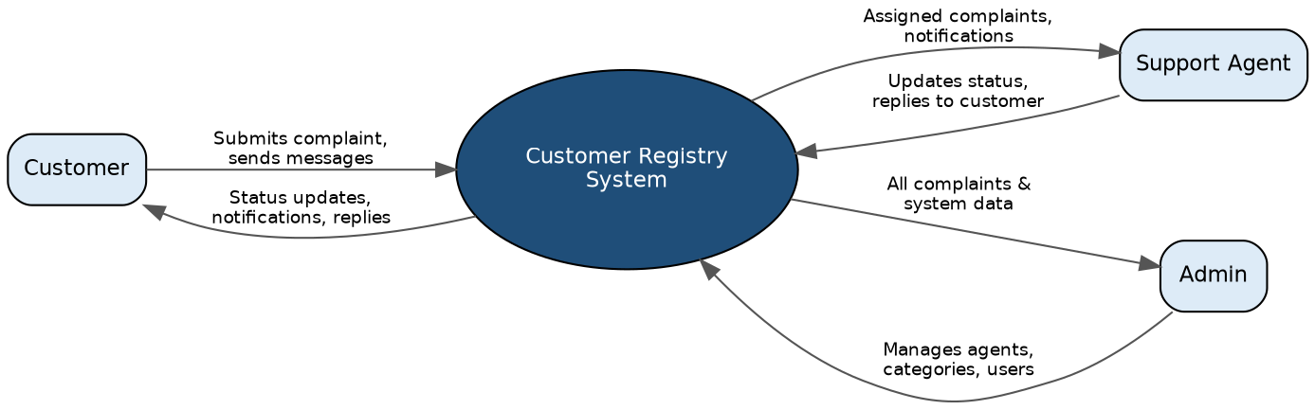
Figure 1: Level-0 (Context) DFD – Customer Registry and its three actors

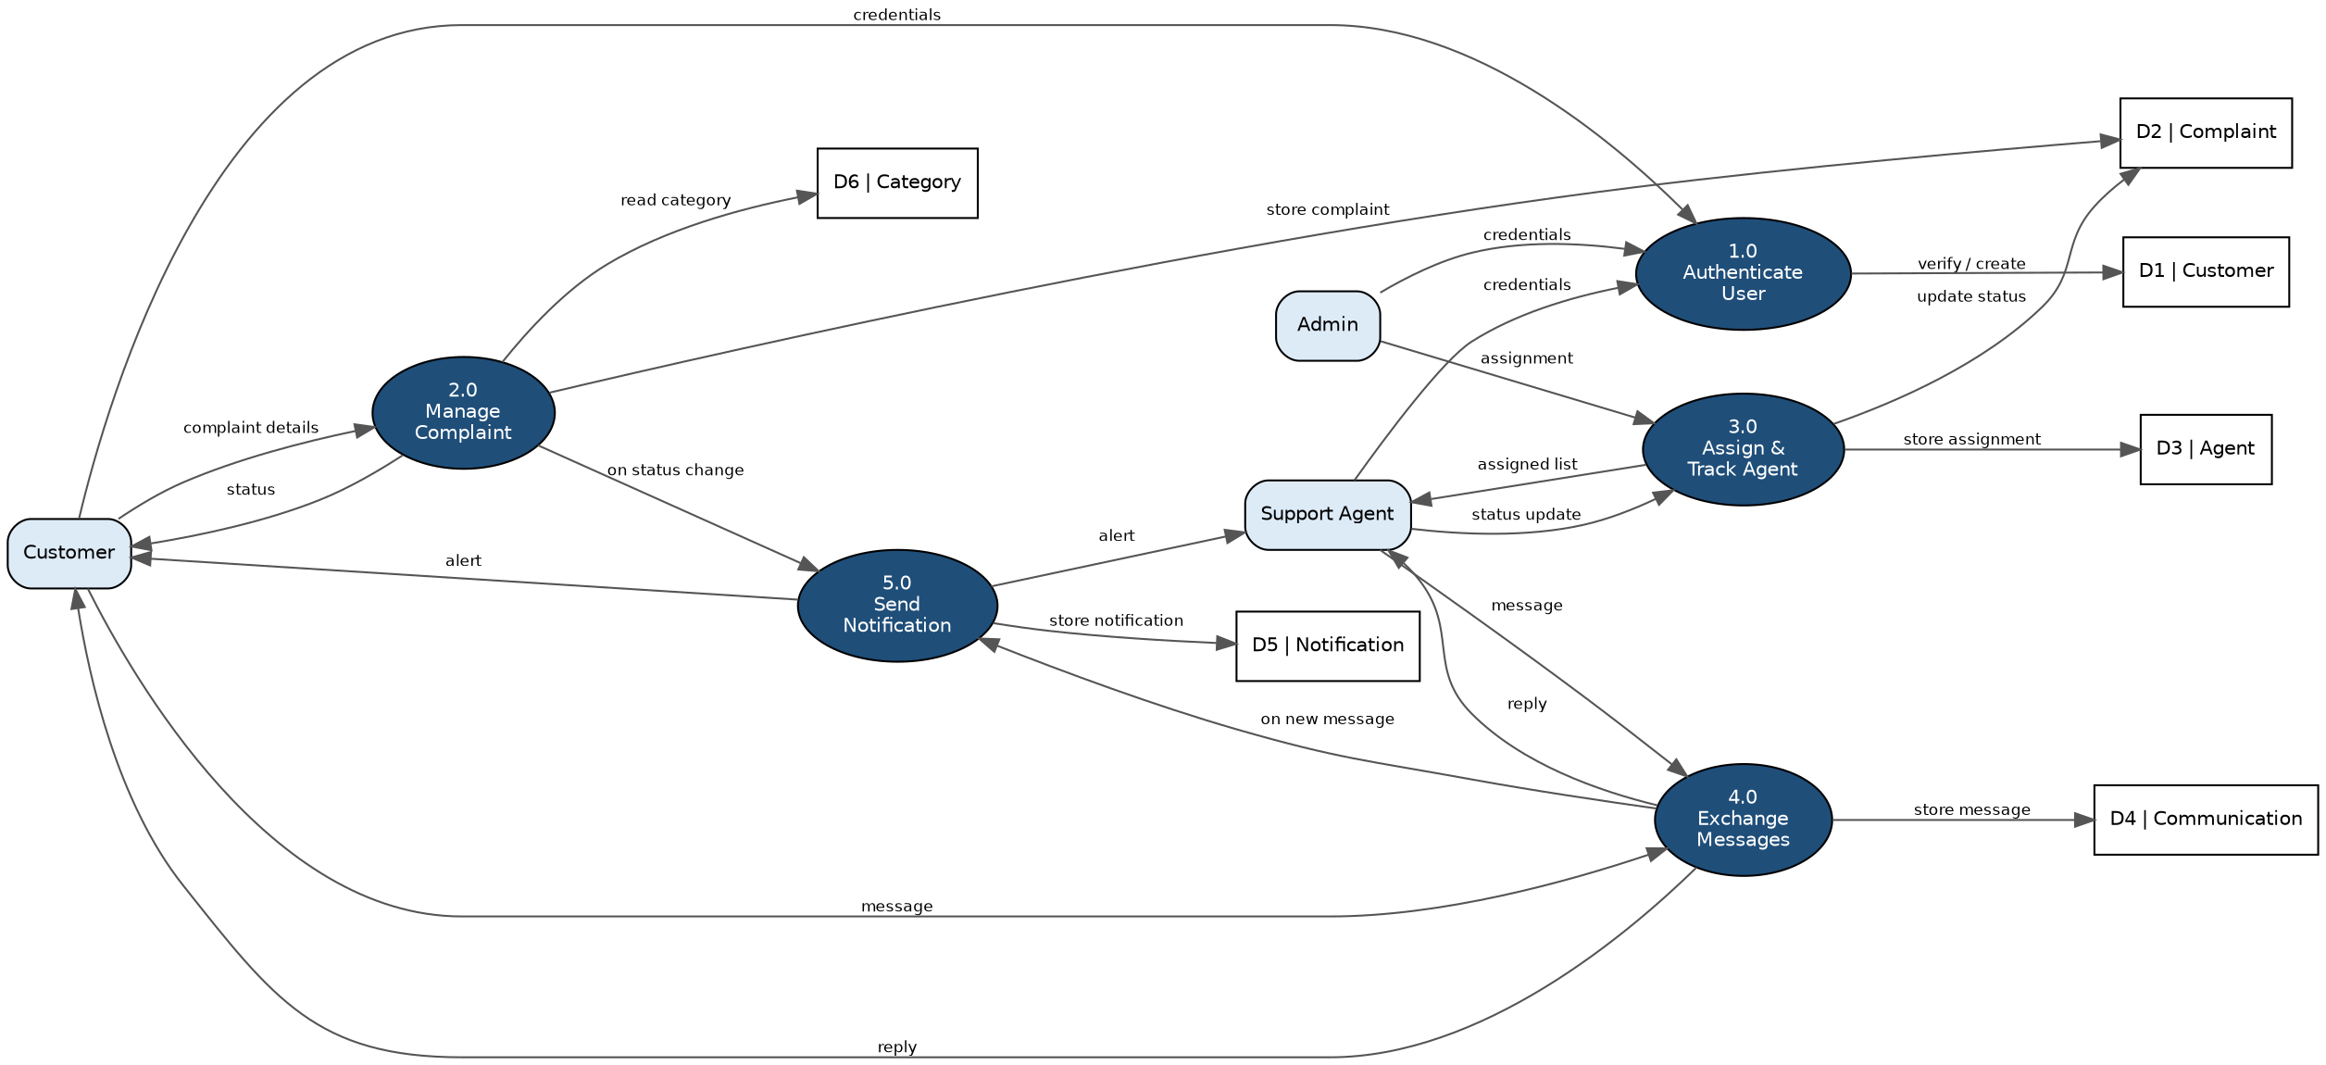
Figure 2: Level-1 DFD – Authenticate, Manage Complaint, Assign & Track, Exchange Messages, Send Notification
User Stories
Use the below template to list all the user stories for the product.
User Type | Functional Requirement (Epic) | User Story Number | User Story / Task | Acceptance Criteria | Priority | Release
Customer | Registration | USN-1 | As a customer, I can register with my name, email and password so that I can log complaints. | I can log in immediately after registering | High | Sprint-1
Customer | Registration | USN-2 | As a customer, I can log in with my email and password to access my dashboard. | I land on my complaint dashboard after login | High | Sprint-1
Customer | Complaint Management | USN-3 | As a customer, I can submit a complaint with my contact details and a description. | The complaint appears in my list with status “pending” | High | Sprint-1
Customer | Complaint Management | USN-4 | As a customer, I can view the current status of each complaint I have raised. | Status shown is one of pending / in-progress / resolved | High | Sprint-1
Customer | Communication | USN-5 | As a customer, I can message the agent assigned to my complaint. | My message appears in the conversation thread instantly | Medium | Sprint-2
Customer | Notifications | USN-6 | As a customer, I receive an in-app notification when my complaint status changes. | A new notification appears in my notification feed | Medium | Sprint-2
Support Agent | Agent Workspace | USN-7 | As an agent, I can view only the complaints that are assigned to me. | My dashboard lists exactly my assigned complaints, no others | High | Sprint-2
Support Agent | Agent Workspace | USN-8 | As an agent, I can update the status of a complaint I am working on. | The customer sees the updated status immediately | High | Sprint-2
Support Agent | Communication | USN-9 | As an agent, I can reply to a customer's message from within the complaint. | My reply appears in the customer's conversation thread | Medium | Sprint-2
Admin | Admin Console | USN-10 | As an admin, I can view every complaint in the system regardless of agent. | The admin complaint list matches the full Complaint collection | High | Sprint-3
Admin | Admin Console | USN-11 | As an admin, I can assign a complaint to a specific agent. | The complaint appears on that agent's dashboard afterward | High | Sprint-3
Admin | Category Management | USN-12 | As an admin, I can add and list complaint categories. | A newly added category is selectable on the complaint form | Medium | Sprint-3

